Name: ______________________________ Class: _______

**Unit 9: What are you wearing? (Grade 3)**

EXERCISE

**I. Look and write.**

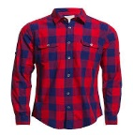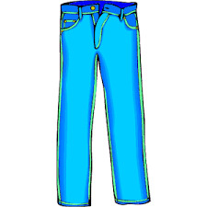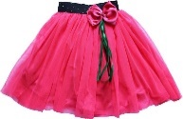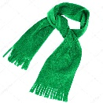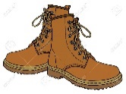

1. _______ 2. _______ 3. ________ 4. ________ 5. _________

**II. Look at the pictures and complete the sentences.**



What’s he wearing?

***He’s wearing*** a yellow ***T-shirt*** and blue ***shorts***.



What’s he wearing?

…………………….. blue ……….. .





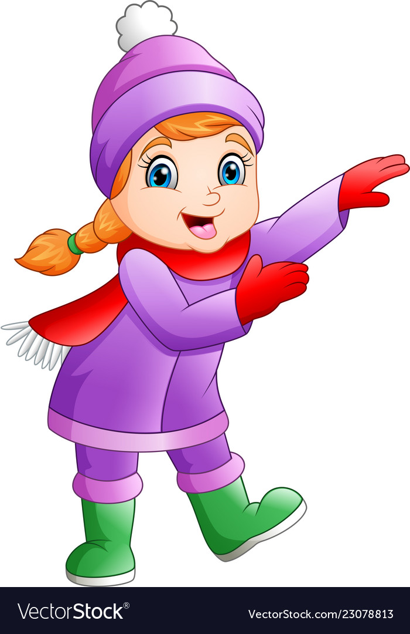

What’s she wearing?

………………. a red ……… and green ………..

1. 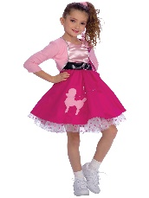

What's she wearing?

……………….a pink ……….. .

**III. Put a tick (🗸) or a cross (🗴)**

**1.**



This is a slide.

**2.**

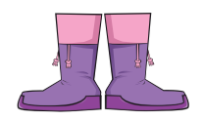

These are boots.

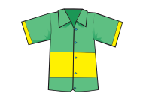

**3.**

This is a scarf.

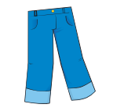

**4.**

These are pants.

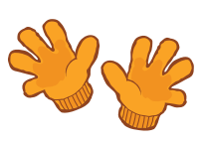

**5.**

These are socks.

**🕮 Good luck to you! ☺**

**ANSWER KEY**

**I. Look and write.**

1. boots

2. shirt

3. pants

4. skirt

5. scarf

**II. Look at the picture and complete the sentence.**

1. *He’s wearing* a yellow *T-shirt* and blue *shorts*.

2. *He’s wearing* blue *pants.*

3. *She’s wearing* a red *scarf* and green *boots.*

4. *She’s wearing* a pink *skirt* .

**III. Put a tick (🗸) or a cross (🗴)**



**1.**

**🗸**

This is a slide.

**2.**

**🗸**



These are boots.



**3.**

**🗴**

This is a scarf.



**4.**

These are pants.

**🗸**



**5.**

These are socks.

**🗴**